caAdapter MMS v4.1

Detailed Design Description

7/23/2008


Center for Biomedical Informatics
and Information Technology

Document Change Record
Version Number | Date | Description
1.0 | 4/30/2007 | Initial document
2.0 | 10/16/2007 | Revision
3.0 | 7/23/2008 | Revision

TABLE OF CONTENTS
1. Introduction 1
2. Model Mapping SErvice 2
2.1 Object to Data Model Mapping Specification 2
2.1.1 Current Screen Shot 2
2.1.2 Recommended Changes 2
Appendix A – acronym List 4
Reference Documents 5

Introduction
The Detailed Design Description (DDD) describes the application design at a more detailed level than the Software Design Description (SDD). It includes aspects such as the graphical user interface (GUI) and business rules that need to be implemented in the caAdapter v4.0 software to fulfill the intent of the software requirements. The DDD is used in conjunction with the SDD as the basis for implementing the software. It provides the acquirer visibility into the detailed design and provides information needed for software support.
As a companion document, this DDD may refer to the SDD and assumes that readers are familiar with the components and architecture described therein. However, this document is organized from the end-user or functional perspective rather than the developer perspective.
The content has been pulled primarily from informal discussions with team members and from the GForge Tracker bug and feature request lists. Not every item in this document is listed in Tracker. This document does not intend to include all bugs and feature requests in Tracker but overlaps with it substantially and will hopefully contain most of the priority 5 and 4 level items. Items may not be listed in priority order however. Also some items may be referred to in more than one section of this document. Furthermore, some items in Tracker may not be related directly to the modules listed here (e.g. architecture/performance/testing related items) but may still need to be addressed.
Bugs and enhancements are listed as changes to the existing application and are grouped by the different types of mapping. Where the same functionality may be used by more than one type of mapping, the sections may refer to one another. Screen shots are included to help illustrate the current UI, current problems or suggested enhancements.

Model Mapping SErvice

Object to Data Model Mapping Specification

Current Screen Shot
The following illustrates the current state of the Object to Data Model Mapping Specification tab.
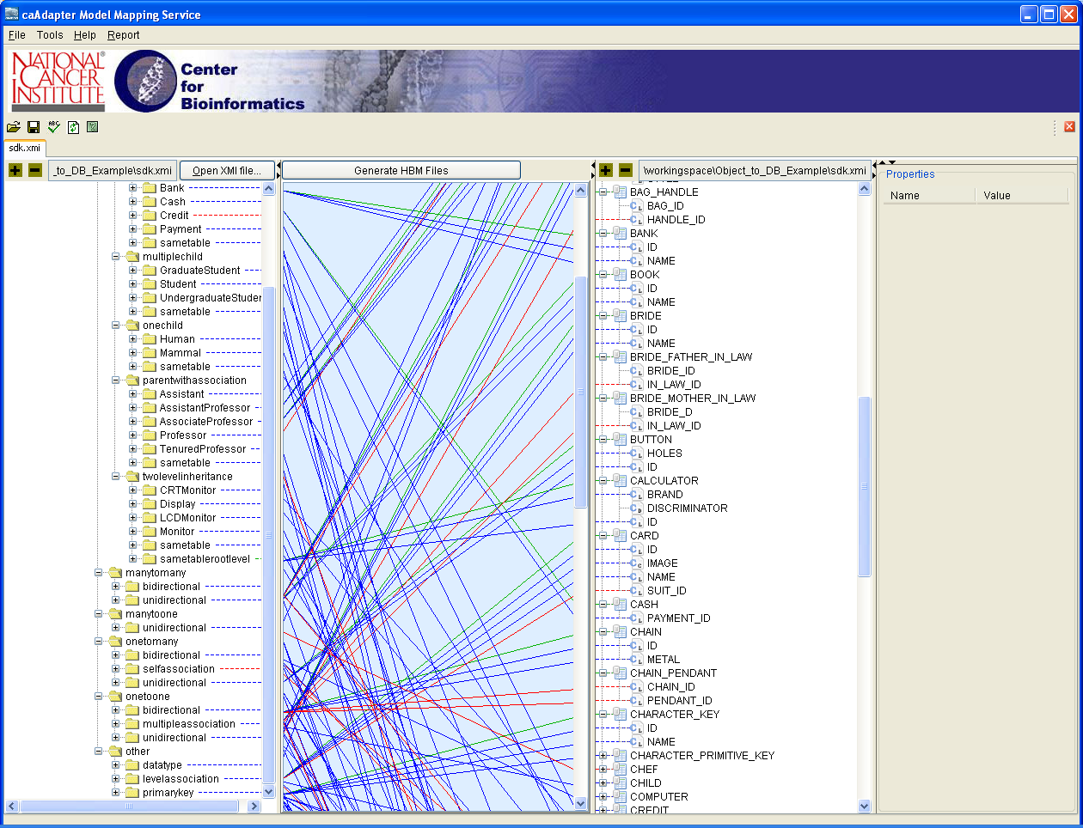
Figure 5-1 Mock-up of Object to Data Model Mapping Specification Tab

Recommended Changes
This section describes the changes that are recommended for the CSV to HL7 v3 Mapping tab. They are in no particular order:
- Add file type recognition for different .map file types and add better error handling to provide messages about using the wrong .map file types in the various map tabs (bug #3430, LOE low/priority 5).
- Add file type recognition for .xmi files and add better error handling to provide messages about using the wrong file types on which to base a model map (bug #3443, LOE low/priority 5).
- Ensure that all Browse features default to the same place the user last navigated to during the current session (bug #3259, LOE/priority are TBD).
- Add mapping type title on the tab to distinguish it from other mapping types (bug #3466, LOE low/priority 4).
- Remove the gray/white striping of every other line in both the source and target trees – this doesn’t help the readability and adds confusion since we now have other colors that indicate that a node is not mappable or is added expressly for the purposes of facilitating mapping for a uni-directional association.
- Change the node highlighting colors for the non-mappable nodes and the nodes added expressly for the purposes of facilitating mapping for a uni-directional association:
  - non-mappable nodes from dark grey/blue to red (intuitively meaning “stop”, maybe with white text for readability),
  - mappable uni-directional association node from pink to green (intuitively meaning, “go”, maybe with white text also).
- Add a Remove All Lines button that removed all mapping lines and XMI tags at once so user doesn’t have to manually remove each one to start over (feature request #3162 and bug #5896, LOE medium/priority 4).
- Disable the Add Function option in the context menu of the mapping pane in the MMS map tab (bug #4050, LOE low/priority 5).
- Change initial display after selecting XMI file: table nodes should not expand upon first selecting the XMI file; and the 2-click requirement for closing an expanded node should be removed (bug #4076, LOE low/priority 5).
- Change message level of all messages that alert user that element is unmapped – should be WARNING, not ERROR or INFO (bug #5898, LOE/priority are TBD).

Appendix A – acronym List

Acronym | Description
DB | Database
DDD | Detailed Design Description
GUI | Graphical User Interface
LOE | Level of Effort
MMS | Model Mapping Service
PM | Project Manager
RTM | Requirements Traceability Matrix
SCM | Software Configuration Management
SDD | Software Design Description
SDP | Software Development Plan
SM | Software Manager
SOP | Standard Operating Procedure
SPE | Software Product Engineering
SRS | Software Requirement Specification
TBD | To Be Determined
XMI | XML Metadata Interchange
XML | Extensible Markup Language

Reference Documents
- caAdapter-3.2_DesignDoc.doc [For caAdapter Version 3.2]
- caAdapter-3.2.0.1_DesignDoc.doc [For caAdapter Version 3.2.0.1]
- caAdapter-4.0_DesignDoc.doc [For caAdapter Version 4.0]
- caAdapter-4.0_Use_Case.doc
- caAdapter-4.0_Software_Requirements_Doc.doc
- caAdapter-4.0_Requirements_UseCase_Tracability.doc

